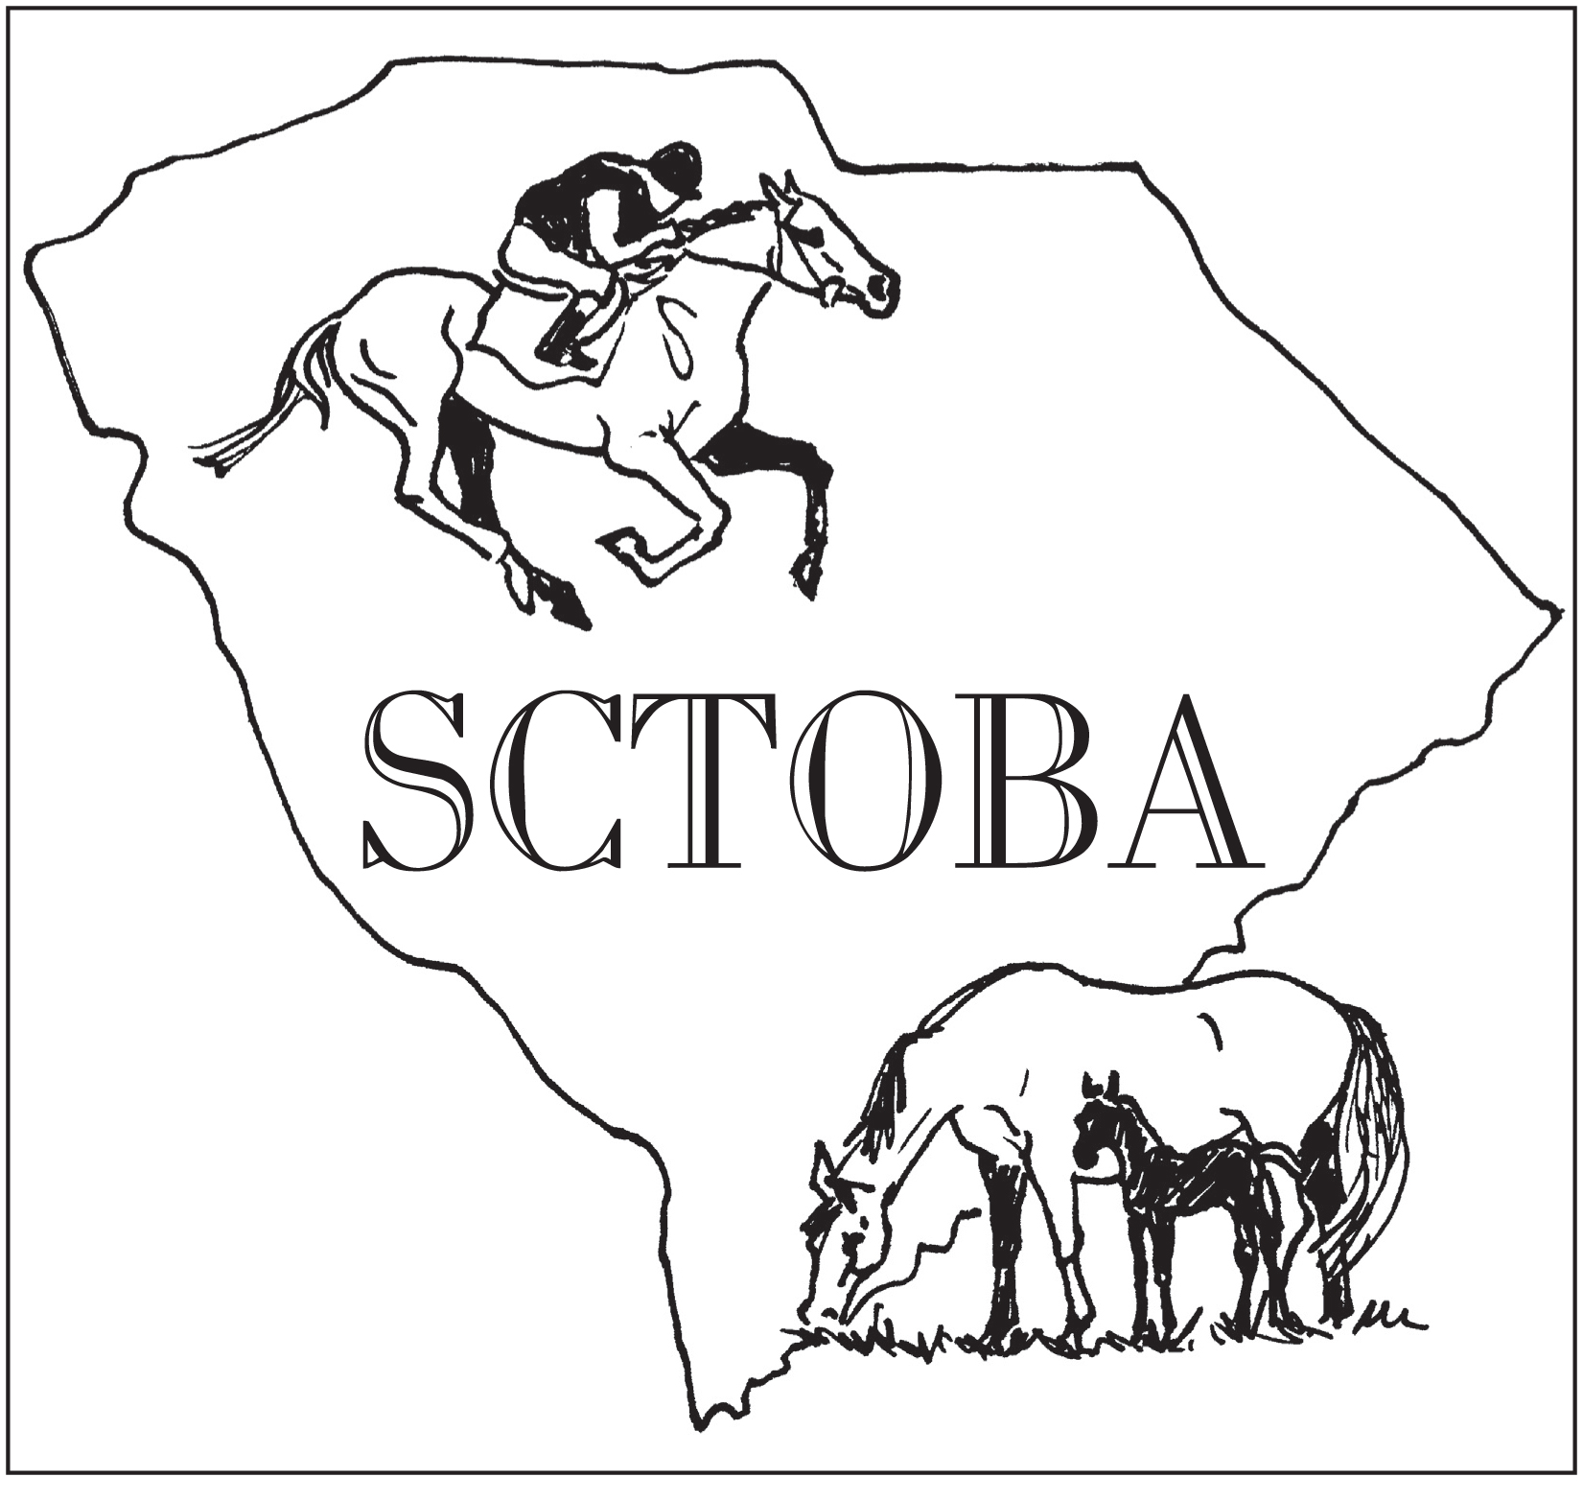
South Carolina Thoroughbred Owners and Breeders Association
Membership Application 2017
c/o Jack Sadler
101 Ellenton Street SE, Aiken, SC 29803

Date:__________________________

Name:___________________________________________________________________

Address:________________________________________________________________

City/State/Zip:_________________________________________________________

Phone:___________________________ Fax:__________________________________

Email:___________________________________________________________________
Annual Dues: $75.00

What are your interests?
Please check all that apply

_____Racing _____Breeding
_____Owner _____Stallions
_____Training _____Boarding

_____Services _____Supplier
_____Farrier _____Feed
_____Veterinarian _____Tack
_____Other
_____Steeplechase
_____Show
_____ Hunter / Jumper _____Other
______ Dressage
_______Eventing

